CREATE HTML PAGES

TEAM ID : *PNT2022TMID33582*

We use HTML to create the front-end part of the web page. There, we have created 3ThTMLpages-home.html,



Home .html displays the home page. Image .html is used for uploading the image imageprediction.html will showcase the output

0.html is to showcase the result. It tells the action to be performed on imageprediction.html while showcasing the result.

For more information regarding HTML











Home .html looks like this



image.html

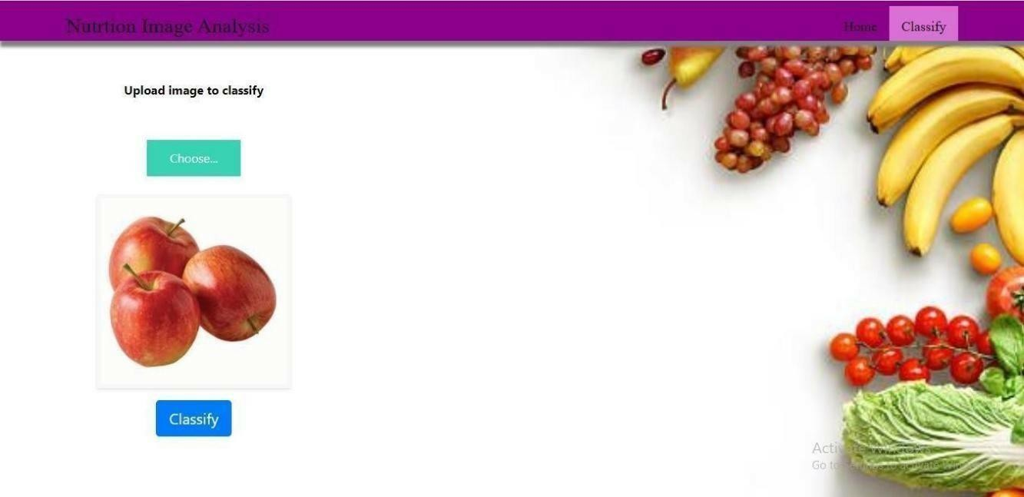

Imageprediction.html

